ITEPE12 213
WEB APPLICATON DEVELOPMENT 2

SUBMITTED BY:

ILON, LORENZEN S.
DE LOS REYES, MYKEL REY B.
GONZALES, JOERIC ISRAEL A.

APRIL 6, 2026

INTRODUCTION

Libraries are fundamental pillars of academic institutions, providing students with access to essential learning materials, references, and resources that support their educational journey. In a campus setting, the library serves as a hub for knowledge, research, and academic excellence. However, as the volume of books and student borrowers grows, managing library operations manually becomes increasingly challenging and prone to human error.
LibroTrack is a web-based Library Management System developed to address the growing needs of campus libraries. The system is designed to digitalize and streamline library operations, making it easier for librarians to manage book records and monitor borrowing activities, while providing students with a convenient portal to browse the library catalog and track their borrowed books.

Problem Statement
Many campus libraries still face significant challenges in their day-to-day operations, including:
- Difficulty in tracking which books are currently borrowed and by whom
- Manual and paper-based recording of borrowing and returning transactions
- Loss or misplacement of borrowing records due to the absence of a centralized system
- Lack of real-time monitoring of book availability, leading to confusion among students and library staff
- Inefficient management of overdue books and penalty records

Why LibroTrack is Important
The development of LibroTrack addresses these problems by providing a structured, digital platform that centralizes all library data and operations. By automating routine tasks such as recording transactions, tracking availability, and monitoring overdue books, LibroTrack enables librarians to focus on providing better service to students. At the same time, the student portal empowers borrowers with direct access to library information, reducing dependency on manual inquiries and improving the overall library experience.

OBJECTIVES

To develop a web-based library management system, LibroTrack, that improves the tracking and management of books and borrowing activities for both librarians and students of the campus library.
Specifically, this system aims to:
- To efficiently manage library book records, including adding, editing, and removing books from the catalog
- To accurately track the borrowing and returning of books, maintaining a complete and up-to-date transaction history
- To monitor book availability in real time, allowing both librarians and students to check which books are currently accessible
- To organize borrower information and provide students with a personal portal to view their active loans, borrowing history, and overdue penalties.

MAIN FUNCTIONS

LibroTrack is composed of two portals — the Admin Portal for librarians and the Student Portal for borrowers. The following are the major functions of the system:

Admin Portal (Librarian)
- Dashboard — Displays a real-time overview of total books, available books, active borrows, overdue records, and registered borrowers
- Book Management — Allows the librarian to add new books, edit existing book information, and remove books from the catalog
- Book Catalog — Provides a searchable and filterable view of all books in the library collection, with grid and list view options
- Borrower Management — Enables the librarian to manage student borrower records, including adding and updating student information
- Borrow & Return — Facilitates the recording of borrowing and returning transactions, automatically updating book availability
- Transaction History — Maintains a complete log of all borrowing and returning activities for audit and reference purposes
- Overdue & Penalty Tracking — Identifies overdue books and calculates corresponding penalties based on the number of days overdue
- Reports — Generates summaries of library activity, including most borrowed books, active borrowers, and monthly transaction counts

Student Portal (Client)
- Browse Books / Catalog — Students can search and browse the library's full book catalog and check real-time availability
- Borrow Request — Students can submit a request to borrow a specific book through the system
- My Borrowed Books — Displays the student's currently borrowed books along with due dates and overdue warnings
- My Borrow History — Shows the student's complete past borrowing transactions

INTENDED USERS

LibroTrack is designed for two types of users within the campus library system:

1. Librarian / Library Staff (Admin)
The librarian or library staff member is the primary administrator of the system. This user is responsible for managing all library operations, including maintaining book records, processing borrow and return transactions, monitoring overdue books, and generating reports. Librarian accounts are pre-configured by the system and are not open for public registration, ensuring that administrative access remains secure and controlled.

2. Students (Client)
Students are the primary end-users of the library's borrowing services. Through the LibroTrack student portal, they can browse the library catalog, check book availability, view their currently borrowed books, monitor due dates, and review their borrowing history. Students can create their own accounts through the registration feature available on the login page. The student portal is designed to be simple, intuitive, and accessible, reducing the need for students to approach library staff for routine inquiries.

ERD (ENTITY RELATIONSHIP DIAGRAM)
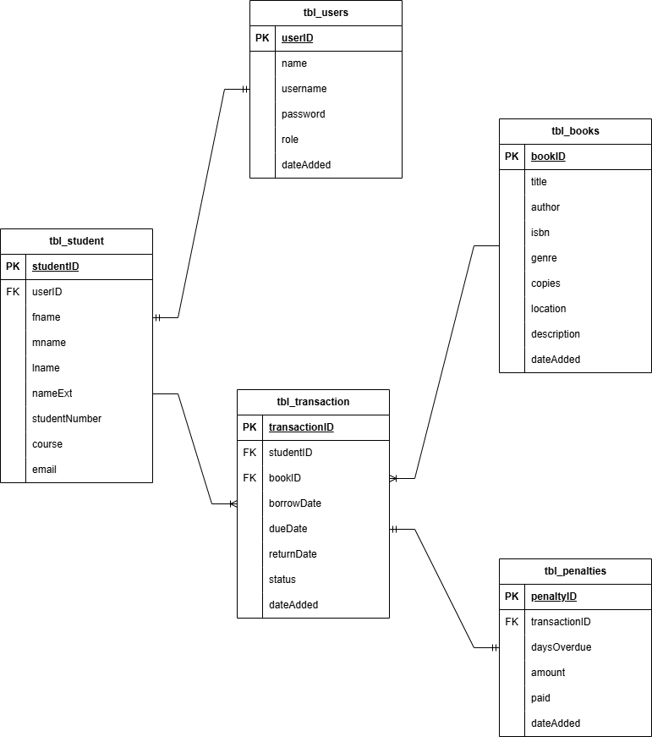

DATA DICTIONARY

This data dictionary defines all tables, fields, data types, and constraints used in the LibroTrack Library Management System database. The system uses MySQL as its database management system.
Table 1: tbl_users
Stores login credentials for both admin (librarian) and student accounts.
Field Name | Data Type | Description | Constraints
userID | INT UNSIGNED | Unique identifier for each user | PK, AUTO_INCREMENT
name | VARCHAR(100) | Full name of the user | NOT NULL
username | VARCHAR(50) | Username used for login | NOT NULL, UNIQUE
password | VARCHAR(255) | Hashed password for authentication | NOT NULL
role | ENUM | Role of the user: 'admin' or 'student' | NOT NULL
dateAdded | TIMESTAMP | Date and time the account was created | DEFAULT CURRENT_TIMESTAMP
Table 1 — tbl_users field definitions

Table 2: tbl_student
Stores additional profile information for student users.
Field Name | Data Type | Description | Constraints
studentID | INT UNSIGNED | Unique identifier for each student record | PK, AUTO_INCREMENT
userID | INT UNSIGNED | References the associated user account | FK → tbl_users.userID
fname | VARCHAR(50) | First name of the student | NOT NULL
mname | VARCHAR(50) | Middle name of the student | NULLABLE
lname | VARCHAR(50) | Last name of the student | NOT NULL
nameExt | VARCHAR(10) | Name extension (e.g. Jr., Sr., III) | NULLABLE
studentNumber | VARCHAR(20) | Official student ID number | NOT NULL, UNIQUE
course | VARCHAR(100) | Course or program the student is enrolled in | NOT NULL
email | VARCHAR(100) | Email address of the student | NOT NULL, UNIQUE
Table 2 — tbl_student field definitions

Table 3: tbl_books
Stores all book records available in the library catalog.
Field Name | Data Type | Description | Constraints
bookID | INT UNSIGNED | Unique identifier for each book | PK, AUTO_INCREMENT
title | VARCHAR(200) | Title of the book | NOT NULL
author | VARCHAR(100) | Name of the book's author | NOT NULL
isbn | VARCHAR(20) | International Standard Book Number | UNIQUE, NULLABLE
genre | VARCHAR(50) | Genre or subject category of the book | NOT NULL
copies | INT UNSIGNED | Total number of copies owned by the library | NOT NULL, DEFAULT 1
location | VARCHAR(100) | Shelf or section location inside the library | NULLABLE
description | TEXT | Brief summary or description of the book | NULLABLE
dateAdded | TIMESTAMP | Date the book was added to the system | DEFAULT CURRENT_TIMESTAMP
Table 3 — tbl_books field definitions

Table 4: tbl_transaction
Records all borrowing and returning activities between students and books.
Field Name | Data Type | Description | Constraints
transactionID | INT UNSIGNED | Unique identifier for each transaction | PK, AUTO_INCREMENT
studentID | INT UNSIGNED | References the student who borrowed the book | FK → tbl_student.studentID
bookID | INT UNSIGNED | References the book that was borrowed | FK → tbl_books.bookID
borrowDate | DATE | Date the book was borrowed | NOT NULL
dueDate | DATE | Expected return date of the borrowed book | NOT NULL
returnDate | DATE | Actual date the book was returned | NULLABLE
status | ENUM | Current status: 'borrowed', 'returned', 'overdue' | NOT NULL
dateAdded | TIMESTAMP | Date and time the transaction was recorded | DEFAULT CURRENT_TIMESTAMP
Table 4 — tbl_transaction field definitions

Table 5: tbl_penalties
Tracks overdue penalties associated with late book returns.
Field Name | Data Type | Description | Constraints
penaltyID | INT UNSIGNED | Unique identifier for each penalty record | PK, AUTO_INCREMENT
transactionID | INT UNSIGNED | References the overdue transaction | FK → tbl_transaction.transactionID
daysOverdue | INT UNSIGNED | Number of days the book was returned late | NOT NULL
amount | DECIMAL(8,2) | Total penalty amount based on days overdue | NOT NULL
paid | BOOLEAN | Whether the penalty has been paid or not | DEFAULT FALSE
dateAdded | TIMESTAMP | Date and time the penalty was recorded | DEFAULT CURRENT_TIMESTAMP
Table 5 — tbl_penalties field definitions

